Project Plan

< Victoria Road Crash Dataset >

Group 52

Student Names

S5219071 Inho Kim

S5234269 Saikat Dutta Tanu

Table of Contents

1.0 Introduction 3

1.1 Problem Background 3

1.2 Scope 3

1.3 Document contents 3

2.0 Work Breakdown Structure 4

3.0 Activity Definition & Estimation 5

4.0 Gantt Chart 6

# Introduction

## Background

The development of this study will be developed to provide road safety data based on time, location, condition, type of collision, type of road user, object hit. based on Victoria Road Crash Dataset provided by VicRoads. To reduce traffic accidents and risks in Victoria. In addition, the software analyses the point of occurrence of an accident and provides visualized insight to help user understand.

## Scope

Document work for this study will be completed prior to the final submission on September 2, including the Gantt Chart, after which the project will be developed according to the schedule assigned to WBS, and the software and all document work will be uploaded to GitHub by October 9, the final project deadline.

## Document contents

The project develops a program that uses data from road crash statistics in Victoria, Australia, for five years from 2015 to 2020, to classify deaths and injuries and analyze data based on user time, location, condition, type of collision, type of road user, object impact, etc.

# Work Breakdown Structure

Our team is organized and each person is assigned a role to complete this project by the project deadline (October 9 and 22). Allocated work is performed on all days except weekends and holidays, and in terms of roles, each has a primary role, which means that we do most of the work and then play a secondary role.

From an external group's point of view, our main external group is the customer. We work closely with our customers to ensure that efficient communication is maintained and their feedback communicates and maintains their vision of the project.

**Member Name:** Inho Kim

**Roles (Primary/Secondary):** Project Manager, Developer/Tester

**Responsibilities:** Inho Kim is in charge of project planning, activity definition, and work schedule, and project development with the roles of project manager, developer

**Member Name:** Saikat Dutta Tanu

**Roles (Primary/Secondary):** Project Designer, Developer/Tester

**Responsibilities:** Saikat is responsible for designing and developing software features and interfaces and he is also responsible for project documentation.

This chart is a project activity that uses elements from WBS to create activity definitions.

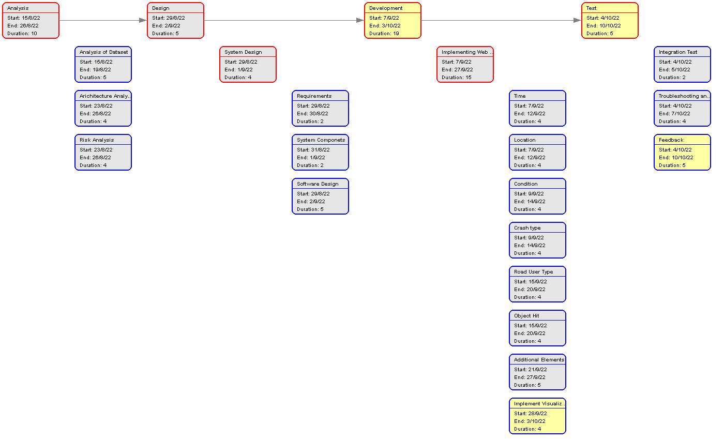

# Activity Definition & Estimation

|  |  |  |  |  |  |  |  |
| --- | --- | --- | --- | --- | --- | --- | --- |
|  | *Task Name* | *Resource* | *Process* | *Start* | *End* | *Duration* | *Progress* |
| *1* | *Analysis* | *IK,ST* | *Completed* | *15-08-22* | *26-08-22* | *10 days* | *100%* |
| *1.1* | *Analysis of Dataset* | *IK* | *Completed* | *15-08-22* | *19-08-22* | *5 days* | *100%* |
| *1.2* | *Architecture Analysis* | *IK* | *Completed* | *23-08-22* | *26-08-22* | *4 days* | *100%* |
| *1.3* | *Risk Analysis* | *IK* | *Completed* | *23-08-22* | *26-08-22* | *4 days* | *100%* |
| *2* | *Design* | *ST* | *Completed* | *29-08-22* | *02-09-22* | *5 days* | *100%* |
| *2.1* | *System Design* | *ST* | *Completed* | *29-08-22* | *01-09-22* | *4 days* | *100%* |
| *2.1.1* | *Requirements* | *ST* | *Completed* | *29-08-22* | *30-08-22* | *2 days* | *100%* |
| *2.1.2* | *System Components* | *ST* | *Completed* | *31-08-22* | *01-09-22* | *2 days* | *100%* |
| *2.2* | *Software Design* | *ST* | *Completed* | *29-08-22* | *02-09-22* | *5 days* | *100%* |
| *3* | *Development* | *IK* | *Completed* | *07-09-22* | *03-10-22* | *19 days* | *-* |
| *3.1* | *Implementing Web Features* | *IK, ST* | *Completed* | *07-09-22* | *27-09-22* | *15 days* | *100%* |
| *3.1.1* | *Time* | *IK, ST* | *Completed* | *07-09-22* | *12-09-22* | *4 days* | *100%* |
| *3.1.2* | *Location* | *IK, ST* | *Completed* | *07-09-22* | *12-09-22* | *4 days* | *100%* |
| *3.1.3* | *Condition* | *IK, ST* | *Completed* | *09-09-22* | *14-09-22* | *4 days* | *100%* |
| *3.1.4* | *Crash Type* | *IK, ST* | *Completed* | *09-09-22* | *14-09-22* | *4 days* | *100%* |
| *3.1.5* | *Road User Type* | *IK, ST* | *Completed* | *15-09-22* | *20-09-22* | *4 days* | *100%* |
| *3.1.6* | *Object Hit* | *IK, ST* | *Completed* | *15-09-22* | *20-09-22* | *4 days* | *100%* |
| *3.1.7* | *Additional Elements* | *IK, ST* | *Completed* | *21-09-22* | *27-09-22* | *5 days* | *100%* |
| *3.2* | *Implement Visualization Capabilities* | IK, ST | *Completed* | *28-09-22* | *03-10-22* | *4 days* | *100%* |
| *4* | *Test* | *ST* | *Completed* | *04-10-22* | *07-10-22* | *5 days* | *100%* |
| *4.1* | *Integration Test* | *IK, ST* | *Completed* | *04-10-22* | *05-10-22* | *2 days* | *100%* |
| *4.2* | *Troubleshooting and Issues* | *IK, ST* | *Completed* | *04-10-22* | *07-10-22* | *4 days* | *100%* |
| *4.3* | *Feedback* | *IK* | *Completed* | *04-10-22* | *07-10-22* | *5 days* | *100%* |

* 1. **Analysis of Dataset**

The data elements of the Victoria Road Crash Dataset were identified and analysed how the program would implement them. The expected work was completed within 5 days.

* 1. **Architecture Analysis**

The elements of the software interface were analyzed that effectively communicate visualized data to customers and build a holistic foundation. The expected work was completed within 4 days.

* 1. **Risk Analysis**

The risk factors of the software were analyzed. The expected work was completed within 4 days

**2.1 System Design**

The system was designed using the elements which was analysed in 1. The work was completed within 4 days.

**2.1.1 Requirements**

The requirements and software requirements were designed and presented by VicRoads. The expected work was completed within 2 days.

**2.1.2 System Components**

System components were designed. The expected work was completed within 2 days.

**2.2 Software Design**

The visual design and functionality of the software were designed. The expected work was completed within 5 days.

**3.1 Implementing Web Features**

The features designed in 2 as web functions were implemented. Contains the CSS to define various images or text. The expected work was completed within 15 days.

**3.1.1 Time**

The time of incident on Victoria State Road should allow data to be available in the order in which the customer needs information. Customers can sort the time of the incident in the latest, oldest order and determine when the incident occurred. The development period was 4 days.

**3.1.2 Location**

Information is provided to customers through statistics on places and places where road accidents occur frequently. Information on the area and location of the accident should be secured to ensure safe operation when the customer reaches the area. The development period was 4 days.

**3.1.3 Condition**

Drivers should be able to identify and print them according to conditions such as drunk driving, hit-and-run, and police attendance. The development period was 4 days.

**3.1.4 Crash Type**

To ensure the customer's collision prevention safety, each type of road accident collision must be provided. The development period was 4 days.

**3.1.5 Road User Type**

It should be possible to classify and statistize the types of road users such as gender classification and illegal driving or the elderly. The development period was four days.

**3.1.6 Object Hit**

Classify people or objects that have crashed on the road. The development period was 4 days.

**3.1.7 Additional Elements**

Design and develop additional features of the project. The development period was 5 days.

**3.2 Implement Visualization Capabilities**

Elements of the developed software should be able to provide statistically visualized data to the user. The development period was 4 days.

**4.1 Integration Test**

Conduct an integrated test prior to the release of the program to determine if there is any abnormality in the functional progression or error. The working period was 2 days.

**4.2 Troubleshooting and Issues**

After the integration test, the final check must be completed by resolving the problem. The working period was 4 days.

**4.3 Feedback**

Improve software quality by actively reflecting feedback from colleagues and customers. The working period is 5 days.

# Gantt Chart

